**Indian Institute of Information Technology, Allahabad**



*MINI PROJECT REPORT*

**On**

**Intelligent Alarm System of Driver Fatigue,**

**based on Video Sequences.**

***Submitted By:***

***Rahul Gupta Amit Kumar Prashant Joshi***

***RIT2011050 RIT2011051 RIT2011056***

***Under the Guidance of:***

Dr. Anupam Agrawal

Professor

IIIT-Allahabad

**11 May, 2014**

**Abstract**

Developing intelligent systems to prevent car accidents can be very effective in minimizing accident death toll. One of the factors which play an important role in accidents is the human errors including driving fatigue relying on new smart techniques; this application detects the signs of fatigue and sleepiness in the face of the person at the time of driving.

The proposed system is based on three separate algorithms. In this model, the person's face is filmed by a camera in the first step by receiving 14-16 fps video sequence. Then, the images are transformed from RGB space into YCbCr and HSV spaces.

The face area is separated from other parts and highly accurate HDP is achieved. That the eyes are open or closed in a specific time interval is determined by focusing on thresholding and equations concerning the symmetry of human faces. The proposed system has been implemented on more than thirty different video sequences with average accuracy of 93.18% and detection rate (DR) of 92.71 % out of approximately 2500 image frames.

High accuracy in segmentation, low error rate and quick processing of input data distinguishes this system from similar ones. This system can minimize the number of accidents caused by drivers' fatigue.

**CANDIDATES’ DELARATION**

We hereby declare that the work presented in this project report entitled “**Intelligent Alarm System of Driver Fatigue, based on Video Sequences**”, submitted towards completion of 6th Semester report of B.Tech. (IT) at Indian Institute of Information Technology, Allahabad, is an authenticated record of our original work carried out from Jan 2014 to Jun 2014 under the guidance of **Prof. Anupam Agrawal**.

Due acknowledgements has been made in the text to all other material used. The project was done in full compliance with the requirements and constraints of the prescribed curriculum.

Date : 11 May, 2014 Submitted by :

Rahul Gupta (RIT2011050)

Amit Kumar (RIT2011051)

Prashant Joshi (RIT2011056)

**CERTIFICATE**

This is to certify that the above statement made by the candidate is correct to the best of my knowledge.

Date : 11 May, 2014 Dr. Anupam Agarwal

Professor

IIIT Allahabad

**Contents**

|  |  |  |
| --- | --- | --- |
| **Sno.** | **Topic** | **Page no.** |
| 1. | **Introduction** | 1 |
| 2. | **Motivation** | 1 |
| 3. | **Problem Definition** | 2 |
| 4. | **Literature Survey** | 3 |
| 5. | **Proposed Approach** | 4 |
| 6. | **Hardware and Software Requirements** | 5 |
| 7. | **Activity Plan Chart** | 6 |
| 8. | **Face Detection using Voila-Jones Algorithm** | 7 |
| 9. | **Eyes and Mouth Detection** | 8 |
| 10. | **Skin Segmentation** | 10 |
| 11. | **Decision Making** | 11 |
| 12. | **Limitations of the Algorithm** | 12 |
| 13. | **Accuracy** | 12 |
| 14. | **References** | 13 |

**Introduction**

Each year hundreds of people lose their lives due to traffic accidents around the world. Unfortunately, Iran ranks first in the world in terms of road fatalities and each year approximately thirty thousands of fellow countrymen lose their lives in these events [I].

The role of human factor in accidents cannot be ruled out; According to national statistics, in 90 to 95 percent of car accidents in Iran, human factor plays a pivotal role. In general, the driver fatigue accounts for 25 percent of accidents and approximately 60 percent of road accidents result in death or serious injury [2]

In a study by the National Transportation Research Institute (NTSRB) in which 107 random car accidents had been selected, fatigue accounted for 58% of the all accidents. A main cause of fatigue is sleeplessness or insomnia.

Ad hoc networks were the first systems to develop the automatic navigation in cars [4] [5]. A noticeable weakness of these systems is that their responses to environmental changes is not real time.

It is especially important in driving where time is a critical factor in driver's decision. On the other hand, another method to check the driver fatigue is monitoring the physical condition and facial expressions of the drivers, which wireless sensor networks are unable to process and transmit these information with adequate precision.

**Motivation**

A common activity in most people’s life is driving; therefore, making driving safe is an important issue in everyday life.

Even though the driver’s safety is improving in road and vehicle design, the total number of serious crashes is still increasing.

Most of these crashes result from impairments of the driver’s attention.

Drowsiness detection can be done in various ways based on the results of different researchers.

The most accurate technique towards driver fatigue detection is dependent on physiological phenomena like brain waves, heart rate etc.

Also different techniques based on the behaviors can be used, which are natural and non-intrusive. These techniques focus on observable visual behaviors from changes in eyes.

(1)

**Problem Definition**

The system deals with using information obtained for the binary version of the image to find the edges of the face, which narrows the area of where the eyes may exist.

Once the face area is found, the eyes are found by computing the horizontal averages in the area. Taking into account the knowledge that eye regions in the face present great intensity changes, the eyes are located by finding the significant intensity changes in the face.

Once the eyes are located, measuring the distances between the intensity changes in the eye area determine whether the eyes are open or closed.

A large distance corresponds to eye closure. If the eyes are found closed for 5 consecutive frames, the system draws the conclusion that the driver is falling asleep and issues a warning signal.

The system is also able to detect when the eyes cannot be found, and works under reasonable lighting conditions.

(2)

**Literature Survey**

|  |  |  |  |  |  |  |  |
| --- | --- | --- | --- | --- | --- | --- | --- |
| **S. No.** | **Publisher Name & Year** | **Paper Title** | **Objective** | **Technique/ Algorithm** | **Merit/ Advantage** | **Demerit/ Disadvantages** | **Future Work** |
| 1  Base Paper | Department of Electrical and Computer- Hakim Sabzevari University of sabzevar | Real-Time Intelligent Alarm System of Driver Fatigue Based on Video Sequences | conducts the detection process by recording the video sequence of the driver's and image processing techniques | Skin segmentati- -on using HSV /YCbCr color spaces + Voila Jones algorithm. | High accuracy in segmentation, low error rate and quick processing of input data. | First valley of histogram need not to be position of eyes always. | Improving the histogram algorithm. |
| 2 | University of Maryland, College Park, MD 20742-3275, USA.Saad A.Sirohey, Azriel Rosenfeld 2000 | Eye detection in a face image using linear and nonlinear filters. | Estimate the size and separation of the eyes | Gabor filters (linear filter),Color-based wedge-shaped (non-linear filter) | A detection rate of 90% was achieved with no false alarms, | When the iris is shifted to either the right or left corner of the eye, only the opposite corner is detected. | Increasing the accuracy. |
| 3 | Technical University of Szczecin Poland Département GE&II, IUT de Troyes, France2009 | A Robust Algorithm for Eye Detection on Gray Intensity Face without Spectacles | Presents a robust eye detection algorithm for gray intensity images. | Storing template of eyes and matching with the existing templates. | Detection accuracy is 95.2%. In addition, the average execution time of proposed algorithm shows that this approach is also quite efficient. | Proposed method doesn’t work so well for the faces with spectacles. | Finding the method which can work well with faces with spectacles. |
| 4 | Department of Computer Engineering, Kashan Branch, Islamic Azad University Kashan, Iran | Driver Drowsiness Detection Using Face Expression Recognition | Proposes and implements a hardware system which is based on infrared light and can be used in resolving accidents due to drowsiness. | Local binary pattern (LBP) histogram. | Independent from environment lighting conditions. | First valley of histogram need not to be position of eyes always. | Improving the histogram algorithm. |
| 5 | Foundation of Computer Science FCS, New York, USA | Drowsiness Detection based on Eye Movement | reduce the number of accidents, and therefore improve the worsening road conditions. | Haar classifier. | Can predict position by observing change in contrast, so cost effective. | Object is higly sensitive to presence of even little other objects. | Improving the algorithm further. |

(3)

**Proposed Approach**

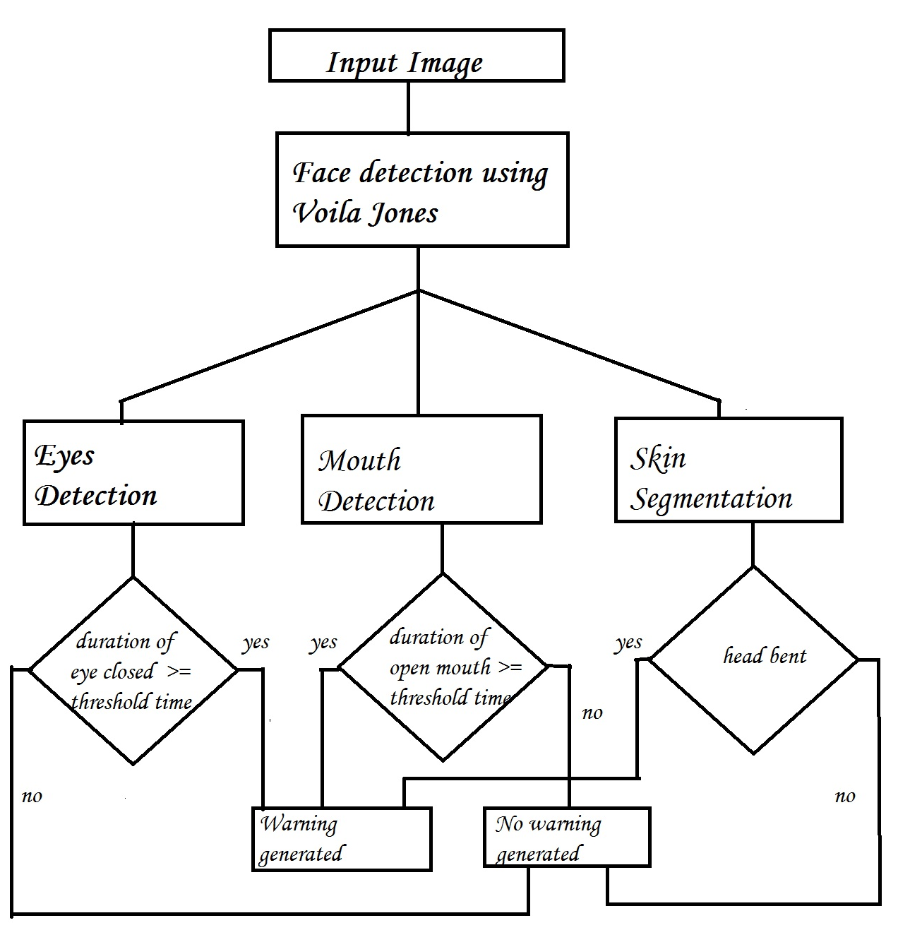

**Figure 1. Flowchart of the algorithm**

(4)

**Hardware & Software Requirements**

The requirements for an effective drowsy driver detection system are as follows:

• A non-intrusive monitoring system that will not distract the driver.

• A real-time monitoring system, to insure accuracy in detecting drowsiness.

• A system that will work in both daytime and nighttime conditions.

• A dedicated system with about 1 GB RAM for the efficiency of the system because due to internal processes of computer, the application will run relatively slow.

The whole system is implemented on MATLAB.

(5)

**Activity Plan Chart**

|  |  |  |
| --- | --- | --- |
| **Activities** | **Before Mid-Sem** | **After Mid-Sem** |
| **Literature Survey** | Completed | Completed |
| **Learning Tools** | MATLAB | MATLAB |
| **Work done** | * Frame Extraction * Converting to grayscale image * Binarization * Extracting eyes off the face | * Mouth Detection * Skin Segmentation * Decision Making |

(6)

**Face Detection using Voila Jones Algorithm**

The **Viola–Jones object detection framework** is the first object detection framework to provide competitive object detection rates in real-time proposed in 2001 by Paul Viola and Michael Jones [3]. Although it can be trained to detect a variety of object classes, it was motivated primarily by the problem of face detection.

In the detection phase of the Viola–Jones object detection framework, a window of the target size is moved over the input image, and for each subsection of the image the Haar-like feature is calculated.[6]

This difference is then compared to a learned threshold that separates non-objects from objects. Because such a Haar-like feature is only a weak learner or classifier (its detection quality is slightly better than random guessing) a large number of Haar-like features are necessary to describe an object with sufficient accuracy.[6]

In the Viola–Jones object detection framework, the Haar-like features are therefore organized in something called a *classifier cascade* to form a strong learner or classifier.[6]

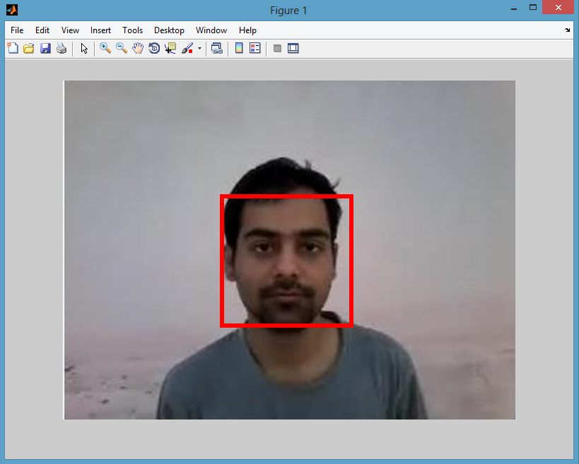 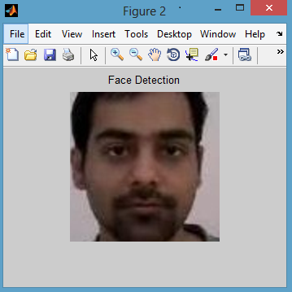

**Figure 2(a) Figure 2(b)**

**Figure 2(a). Face Region after Voila-Jones algorithm is applied.**

**Figure 2(b). Cropped face region.**

**(7)**

**Eyes and Mouth Detection**

After the face is detected using Voila-Jones, the region containing the eyes and mouth has to be separated.

To detect the coordinate from where the region of eye is starting certain calculations are done. After the rectangular window is extracted, we have considered that the eyes are located at a distance of (0.25 * height of window) from the top and (0.15 * width of window) from the left.

The size of window is (0.25 * height of window) in height and (0.68 * width of window) in width.

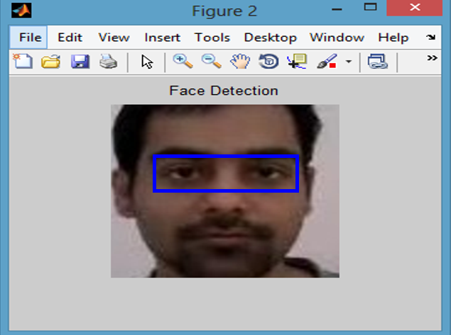 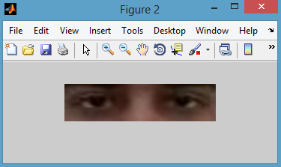

**3(a) 3(b)**

**Figure 3(a). Eye Region after the calculations.**

**Figure 3(b). Cropped eye region.**

After the eyes are cropped the image is coverted to YCbCr. The reason for conversion and way to convert is mentioned in “Skin Segmentation” column. Then image is converted to grayscale and ultimately to binary image by setting a threshold of (minimum pixel value + 10).

**  **

**4(a) 4(b) 4(c)**

**Figure 4(a). Image after converting to YCbCr colour space.**

**Figure 4(b). Image after converting 4(a) to grayscale.**

**Figure 4(c). Image after converting 4(b) to binary image.**

**(8)**

To detect the coordinate from where the region of mouth is starting certain calculations are done. After the rectangular window is extracted, we have considered that the mouth are located at a distance of (0.67 * height of window) from the top and (0.27 * width of window) from the left.

The size of window is (0.20* height of window) in height and (0.45 * width of window) in width.

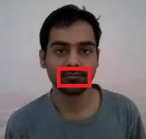 

**5(a) 5(b)**

**Figure 5(a). The region of mouth to be extracted.**

**Figure 5(b). Cropped mouth region.**

Again the mouth is converted to YCbCr colour space, then it is converted to grayscale image and in turn converted to binary image with a threshold of (minimum pixel value + 10).

  

**6(a) 6(b) 6(c)**

**Figure 6(a). Mouth region converted to YCbCr colour space.**

**Figure 6(b). After converting 6(a) to grayscale image.**

**Figure 6(c). After converting 6(b) to binary image.**

**(9)**

**Skin Segmentation**

An image which taken inside a vehicle includes the driver’s face. Typically a camera takes images within the RGB model (Red, Green and Blue). However, the RGB model includes brightness in addition to the colours. When it comes to human’s eyes, different brightness for the same color means different colour.

When analyzing a human face, RGB model is very sensitive in image brightness. Therefore, to remove the brightness from the images is second step. We use the YCbCr space since it is widely used in video compression standards .Since the skin-tone color depends on luminance, we nonlinearly transform the YCbCr colour space to make the skin cluster luma-independent. This also enables robust detection of dark and light skin tone colours. The main advantage of converting the image to the YCbCr domain is that influence of luminosity can be removed during our image processing.

In the RGB domain, each component of the picture (red, green and blue) has a different brightness. However, in the YCbCr domain all information about the brightness is given by the Y component, since the Cb (blue) and Cr (red) components are independent from the luminosity.

**Conversion from RGB to YCbCr**

Cb = (0.148* Red) - (0.291* Green) + (0.439 * Blue) + 128;

Cr = (0.439 * Red) - (0.368 * Green) – (0.071 * Blue) + 128;

**Conversion from RGB to HSV**

MATLAB has predefined function for conversion of RGB color space to HSV color space.

I’ = rgb2hsv (I);

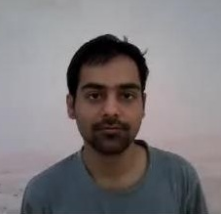  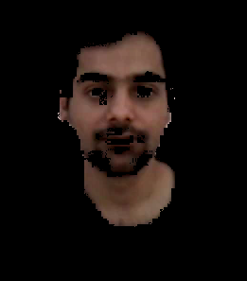

**7(a) 7(b)**

**Figure 7(a). Image before skin segmentation.**

**Figure 7(b). Image after skin segmentation.**

**(10)**

**Decision Making**

**The first frame is used for learning. All the results are calculated taking first frame as ideal frame.**

**Eyes Closed**

When eyes are closed, the number of black pixels in binary image decreases considerably.

If eyes are found closed for atleast 2 consecutive seconds (i.e. 2 * 16 = 32 frames, considering 16 frames per second), then the warning will be generated.

**Mouth Open**

When mouth is open, the resulting black pixels in binary image can be considerably larger or smaller than the ideal frame. The difference can be more than 6% of the black pixels in ideal frame.

If mouth is found open for atleast 2 consecutive seconds (i.e. 2 * 16 = 32 frames, considering 16 frames per second), it means that the person is yawning and in response the warning will be generated.

**Head Lowering**

If the head is lowered, or turned around the number of skin pixels considerably decrease as compared to the ideal frame.

If head is found lowered or found turned in other directions for atleast 2 consecutive seconds (i.e. 2 * 16 = 32 frames, considering 16 frames per second), it means that the person is vulnerable for accident and in response the warning will be generated.

(11)

**Limitations of the algorithm**

* Objects in the video, should be uniformly illuminated, else results can differ.
* Changing distance of person from the camera can cause problems.
* Head lowering can give abrupt results in case of bald person.
* The algorithm doesn’t work for the people sleeping with eyes open.
* Face symmetry calculations are not same for everyone. The calculations considered are true for most of the people.

**Accuracy**

The algorithm is checked on about thirty videos of about 5-10 seconds.

The algorithm gives correct answer on about 25 videos that makes it about 83.33% accurate.

(12)

**References**

[1] G. Hosseini, H. Hossein-Zadeh, A "Display driver drowsiness Warning system", International Conference of the road and traffic accidents, Tehran University, 2006.

[2] L. M Bergasa, J. u. Nuevo, M A. Sotelo, R Barea and E. Lopez, "Visual Monitoring of Driver Inattention," Studies in Computational Intelligence (SCI), 2008.

[3] Viola, Jones: Robust Real-time Object Detection, IJCV 2001 pages 1,3.

[4] C. Zhang, X Lin, R Lu, P.H. Ho, X Shen, "An efficient message authentication scheme for vehicular communications". IEEE Trans Veh TechnoI57(6):3357-3368.2008.

[5] S. S. Manv M.S. Kakkasager J. Pitt, "MuItiagent based infonnation dissemination in vehicular ad hoc networks". Mobile Infonn Syst 5(4 ):363-389.2009.

[6] <http://en.wikipedia.org/wiki/Haar-like_features>

(13)